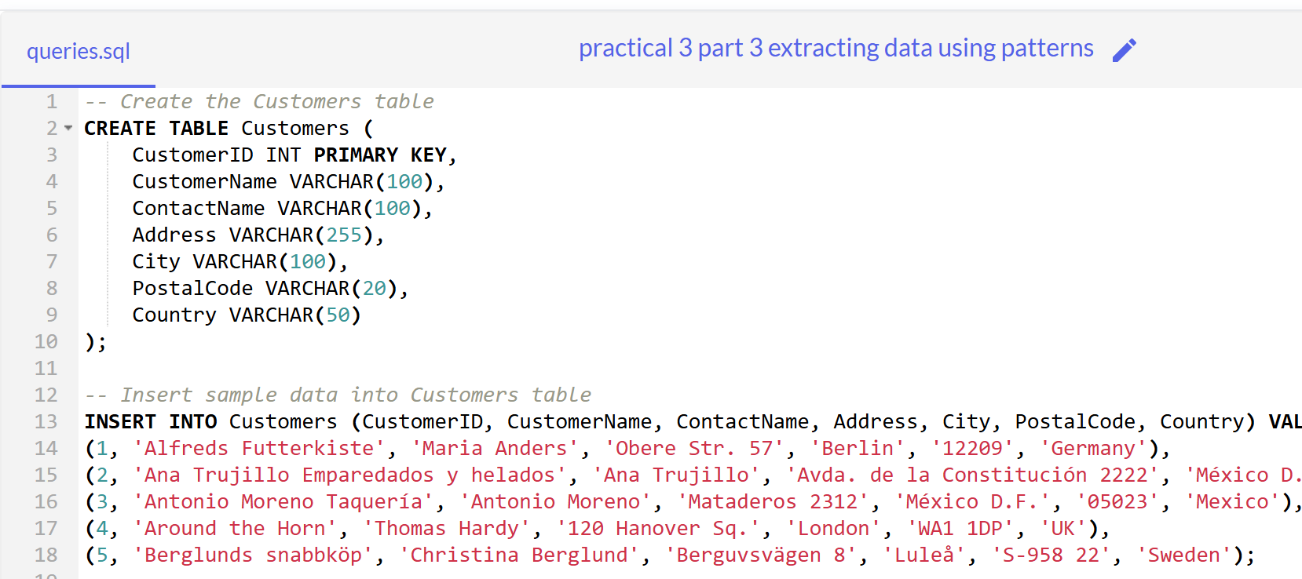

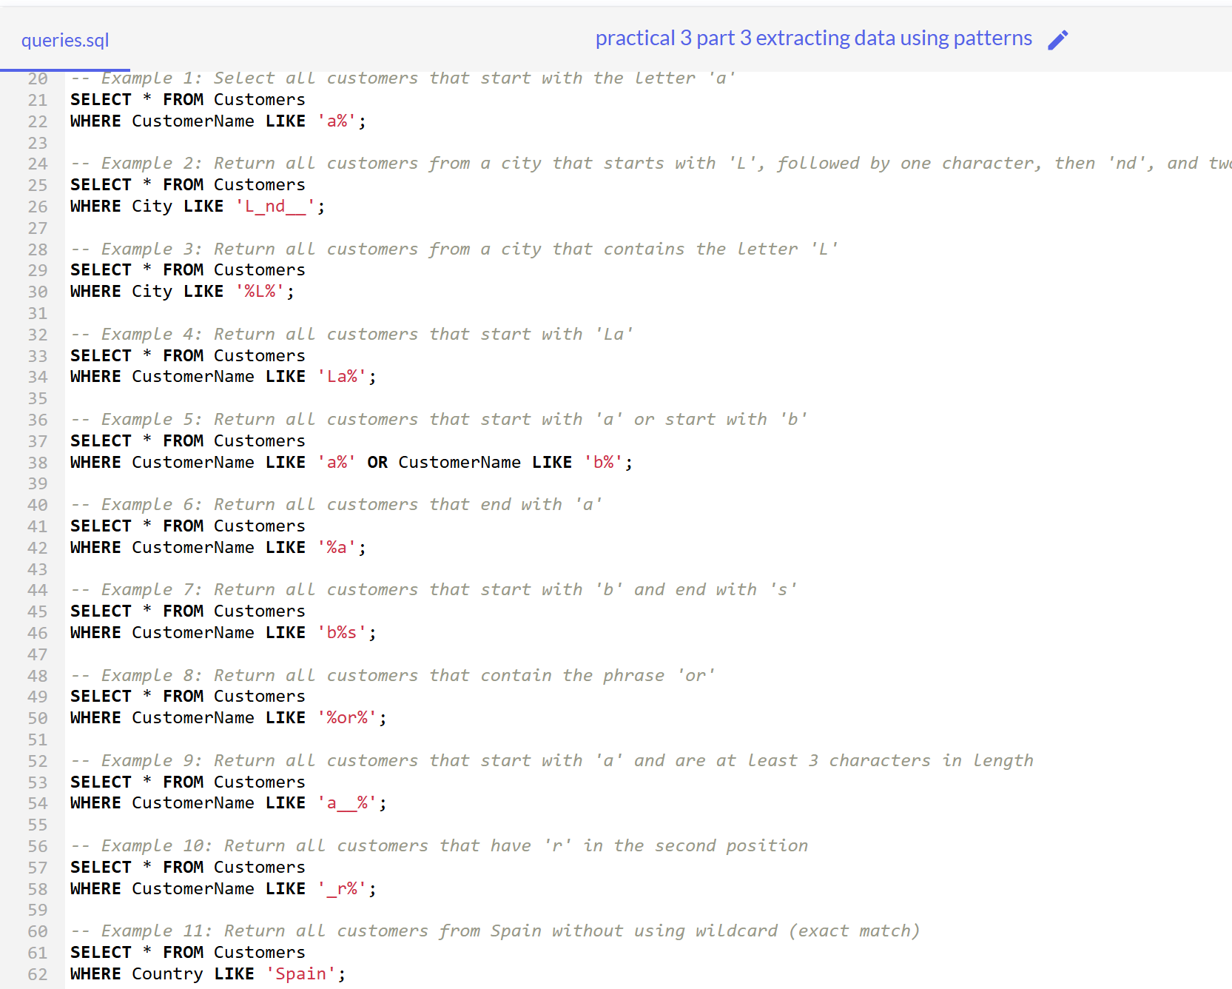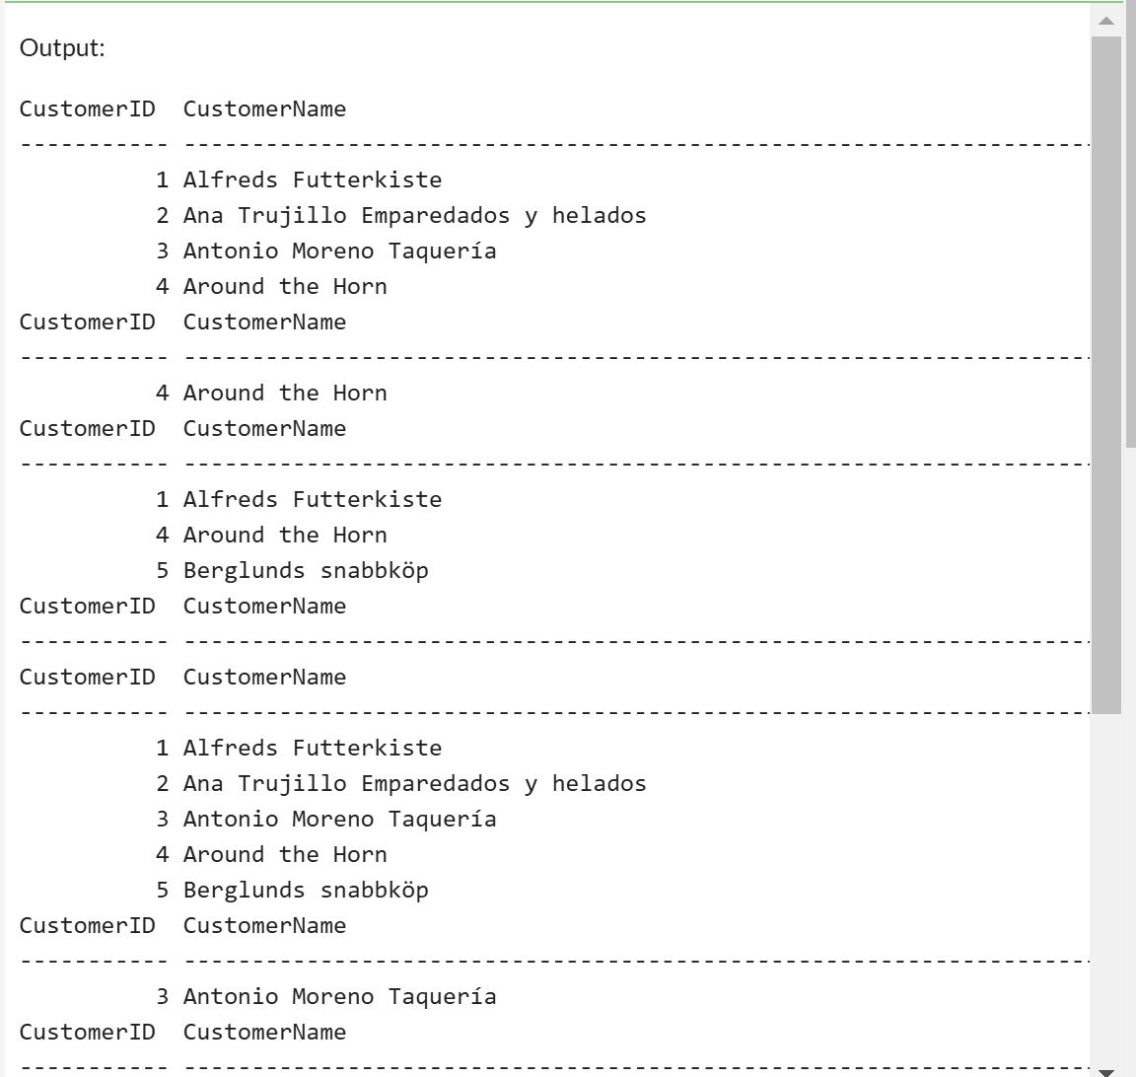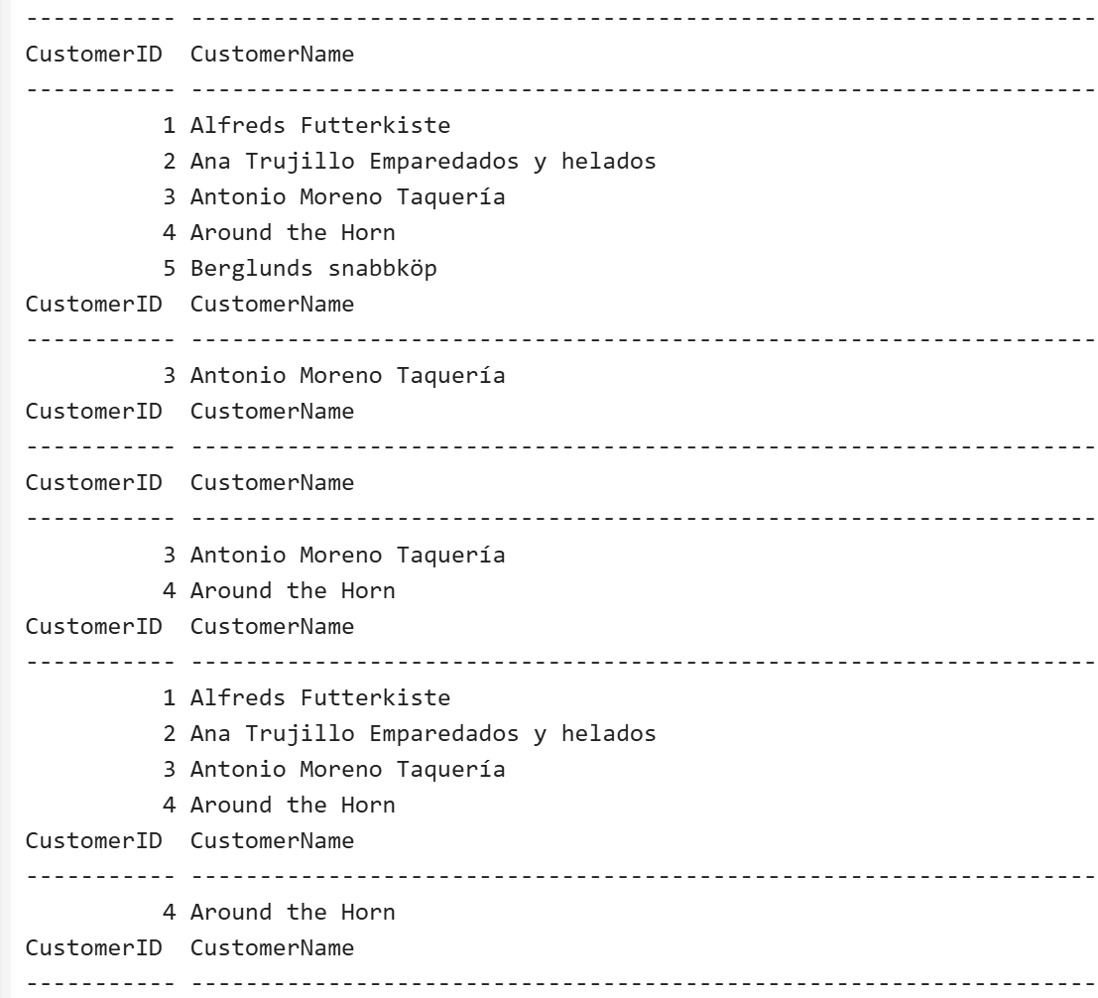

**Extracting data using patterns**

Note: In sample code, change the table name and attributes according to your code.

SQL LIKE Operator

The LIKE operator is used in a WHERE clause to search for a specified pattern in a column. There are two wildcards often used in conjunction with the LIKE operator: • The percent sign % represents zero, one, or multiple characters • The underscore sign _ represents one, single character

Example

Select all customers that starts with the letter "a":

SELECT * FROM Customers

WHERE CustomerName LIKE 'a%';

Demo Database

|  |
| --- |
| **CustomerID CustomerName ContactName Address City PostalCode Country**  1 Alfreds  Maria Anders Obere Str. 57 Berlin 12209 Germany  Futterkiste  2 Ana Trujillo  Ana Trujillo Avda. de la  México  05021 Mexico  Emparedados y  Constitución  D.F.  helados  2222  3 Antonio  Antonio  Mataderos  México  05023 Mexico  Moreno  Moreno  2312  D.F.  Taquería  4 Around the  Thomas  120 Hanover  London WA1 1DP UK  Horn  Hardy  Sq.  5 Berglunds  Christina  Berguvsvägen  Luleå S-958 22 Sweden  snabbköp  Berglund  8 |

The _ Wildcard

The _ wildcard represents a single character.

It can be any character or number, but each _ represents one, and only one, character.

Example

Return all customers from a city that starts with 'L' followed by one wildcard character, then 'nd' and then two wildcard characters:

SELECT * FROM Customers

WHERE city LIKE 'L_nd__';

The % Wildcard

The % wildcard represents any number of characters, even zero characters.

Example

Return all customers from a city that *contains* the letter 'L':

SELECT * FROM Customers

WHERE city LIKE '%L%';

Starts With

To return records that starts with a specific letter or phrase, add the % at the end of the letter or phrase.

Example

Return all customers that starts with 'La':

SELECT * FROM Customers

WHERE CustomerName LIKE 'La%';

**Tip:** You can also combine any number of conditions using AND or OR operators.

Example

Return all customers that starts with 'a' or starts with 'b':

SELECT * FROM Customers

WHERE CustomerName LIKE 'a%' OR CustomerName LIKE 'b%';

Ends With

To return records that ends with a specific letter or phrase, add the % at the beginning of the letter or phrase.

Example

Return all customers that ends with 'a':

SELECT * FROM Customers

WHERE CustomerName LIKE '%a';

**Tip:** You can also combine "starts with" and "ends with":

Example

Return all customers that starts with "b" and ends with "s":

SELECT * FROM Customers

WHERE CustomerName LIKE 'b%s';

Contains

To return records that contains a specific letter or phrase, add the % both before and after the letter or phrase.

Example

Return all customers that contains the phrase 'or'

SELECT * FROM Customers

WHERE CustomerName LIKE '%or%';

Combine Wildcards

Any wildcard, like % and _ , can be used in combination with other wildcards.

Example

Return all customers that starts with "a" and are at least 3 characters in length: SELECT * FROM Customers

WHERE CustomerName LIKE 'a__%';

Example

Return all customers that have "r" in the second position:

SELECT * FROM Customers

WHERE CustomerName LIKE '_r%';

Without Wildcard

If no wildcard is specified, the phrase has to have an exact match to return a result.

Example

Return all customers from Spain:

SELECT * FROM Customers

WHERE Country LIKE 'Spain';